Table of Contents

**Deliverable 5**

Team Captain / Secretary Rotation_________________________________________________**1**

Agenda and Minutes (since Deliverable 4)___________________________________________**2**

EER Diagram_________________________________________________________________**6**

Site Map_____________________________________________________________________**7**

Updated Use Cases____________________________________________________________**8**

Sample Test Results: SQL______________________________________________________**14**

Prototype Test Results: JSP_____________________________________________________**23**

Special Features______________________________________________________________**42**

Captain and Secretary Rotation List

**Deliverable 1**:

Team Chair: Melody

Secretary: Rachael

**Deliverable 2**:

Team Chair: Seth

Secretary: Boen

**Deliverable 3**:

Team Chair: Boen

Secretary: Melody

**Deliverable 4**:

Team Chair: Rachael

Secretary: Seth

**Deliverable 5**:

Team Chair: Melody

Secretary: Rachael

Minutes 5/2

**Start Time**: 10:05

**Members Present:** Melody, Seth, Rachael, Boen

**Decisions:**

-No Tolerance policy implemented

-Tags table must be fixed so it accurately represents the original plan

-Tags table will be deleted and recreated

-Populate Tables

-30-40 tuples

-redo tags data

-replace nonsense data with non-nonsense data

**Work Delegation**

Melody: JSP

Seth: Patching SQL, hashing passwords

Boen: Inserting data into database, 390 database expires on saturday

Rachael: JSP

**Things that still need to be done:**

-Testing

Minutes 5/4

Everyone present, meeting with blaha

**Things to do**

-update user table to remove photo column

-update SQL to remove photos mentioned

**JSP Use Cases**

Rachael: 1

Boen: 2, 3

Melody: 4, 5

Seth: 6

**Notes:**

-Please remember all changes made to Utilities, as they will need to be integrated with each other in order for everything to work.

Minutes 5/8

**Start time:** 10:30

**End Time:** 11:00

**Members Present:** Melody, Seth, Rachael

**Issues Discussed:**

-Finishing the jsp, getting utilities to work with jsp

-Grilling absent member about incomplete/unsatisfactory work

-Completing aforementioned incomplete/unsatisfactory work

Minutes 5/11

**Start Time:** 10:10

**End Time:** 11:00

**Members Present:** Melody, Seth, Boen, Rachael

**Issues Discussed:**

-Getting all jsp files into one folder

-Start “official” testing (i.e. screenshots)

-Assist members with completing/debugging jsp files

**Decisions:**

-Seth will do official testing and gather all jsp files into one project

EER Diagram

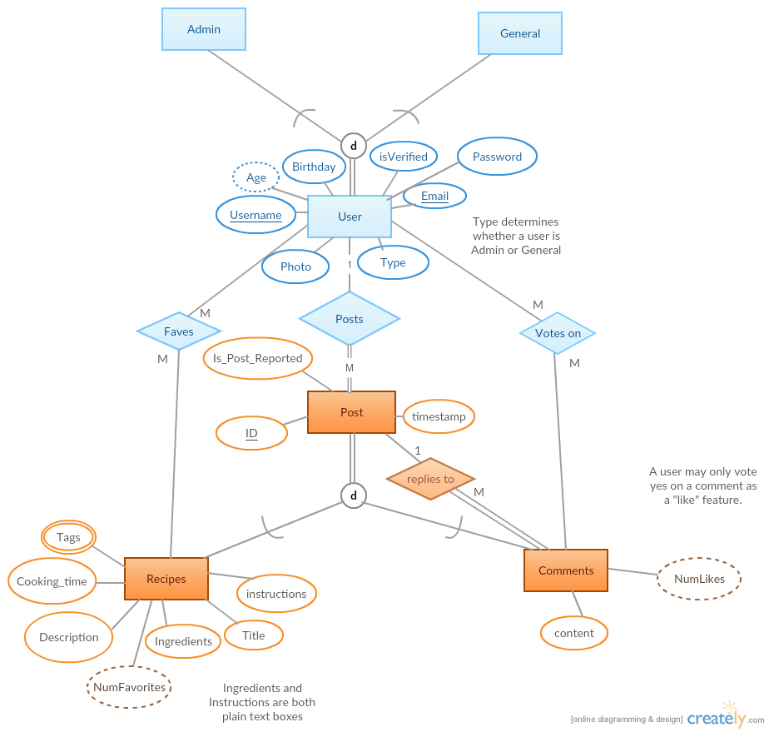

Sitemap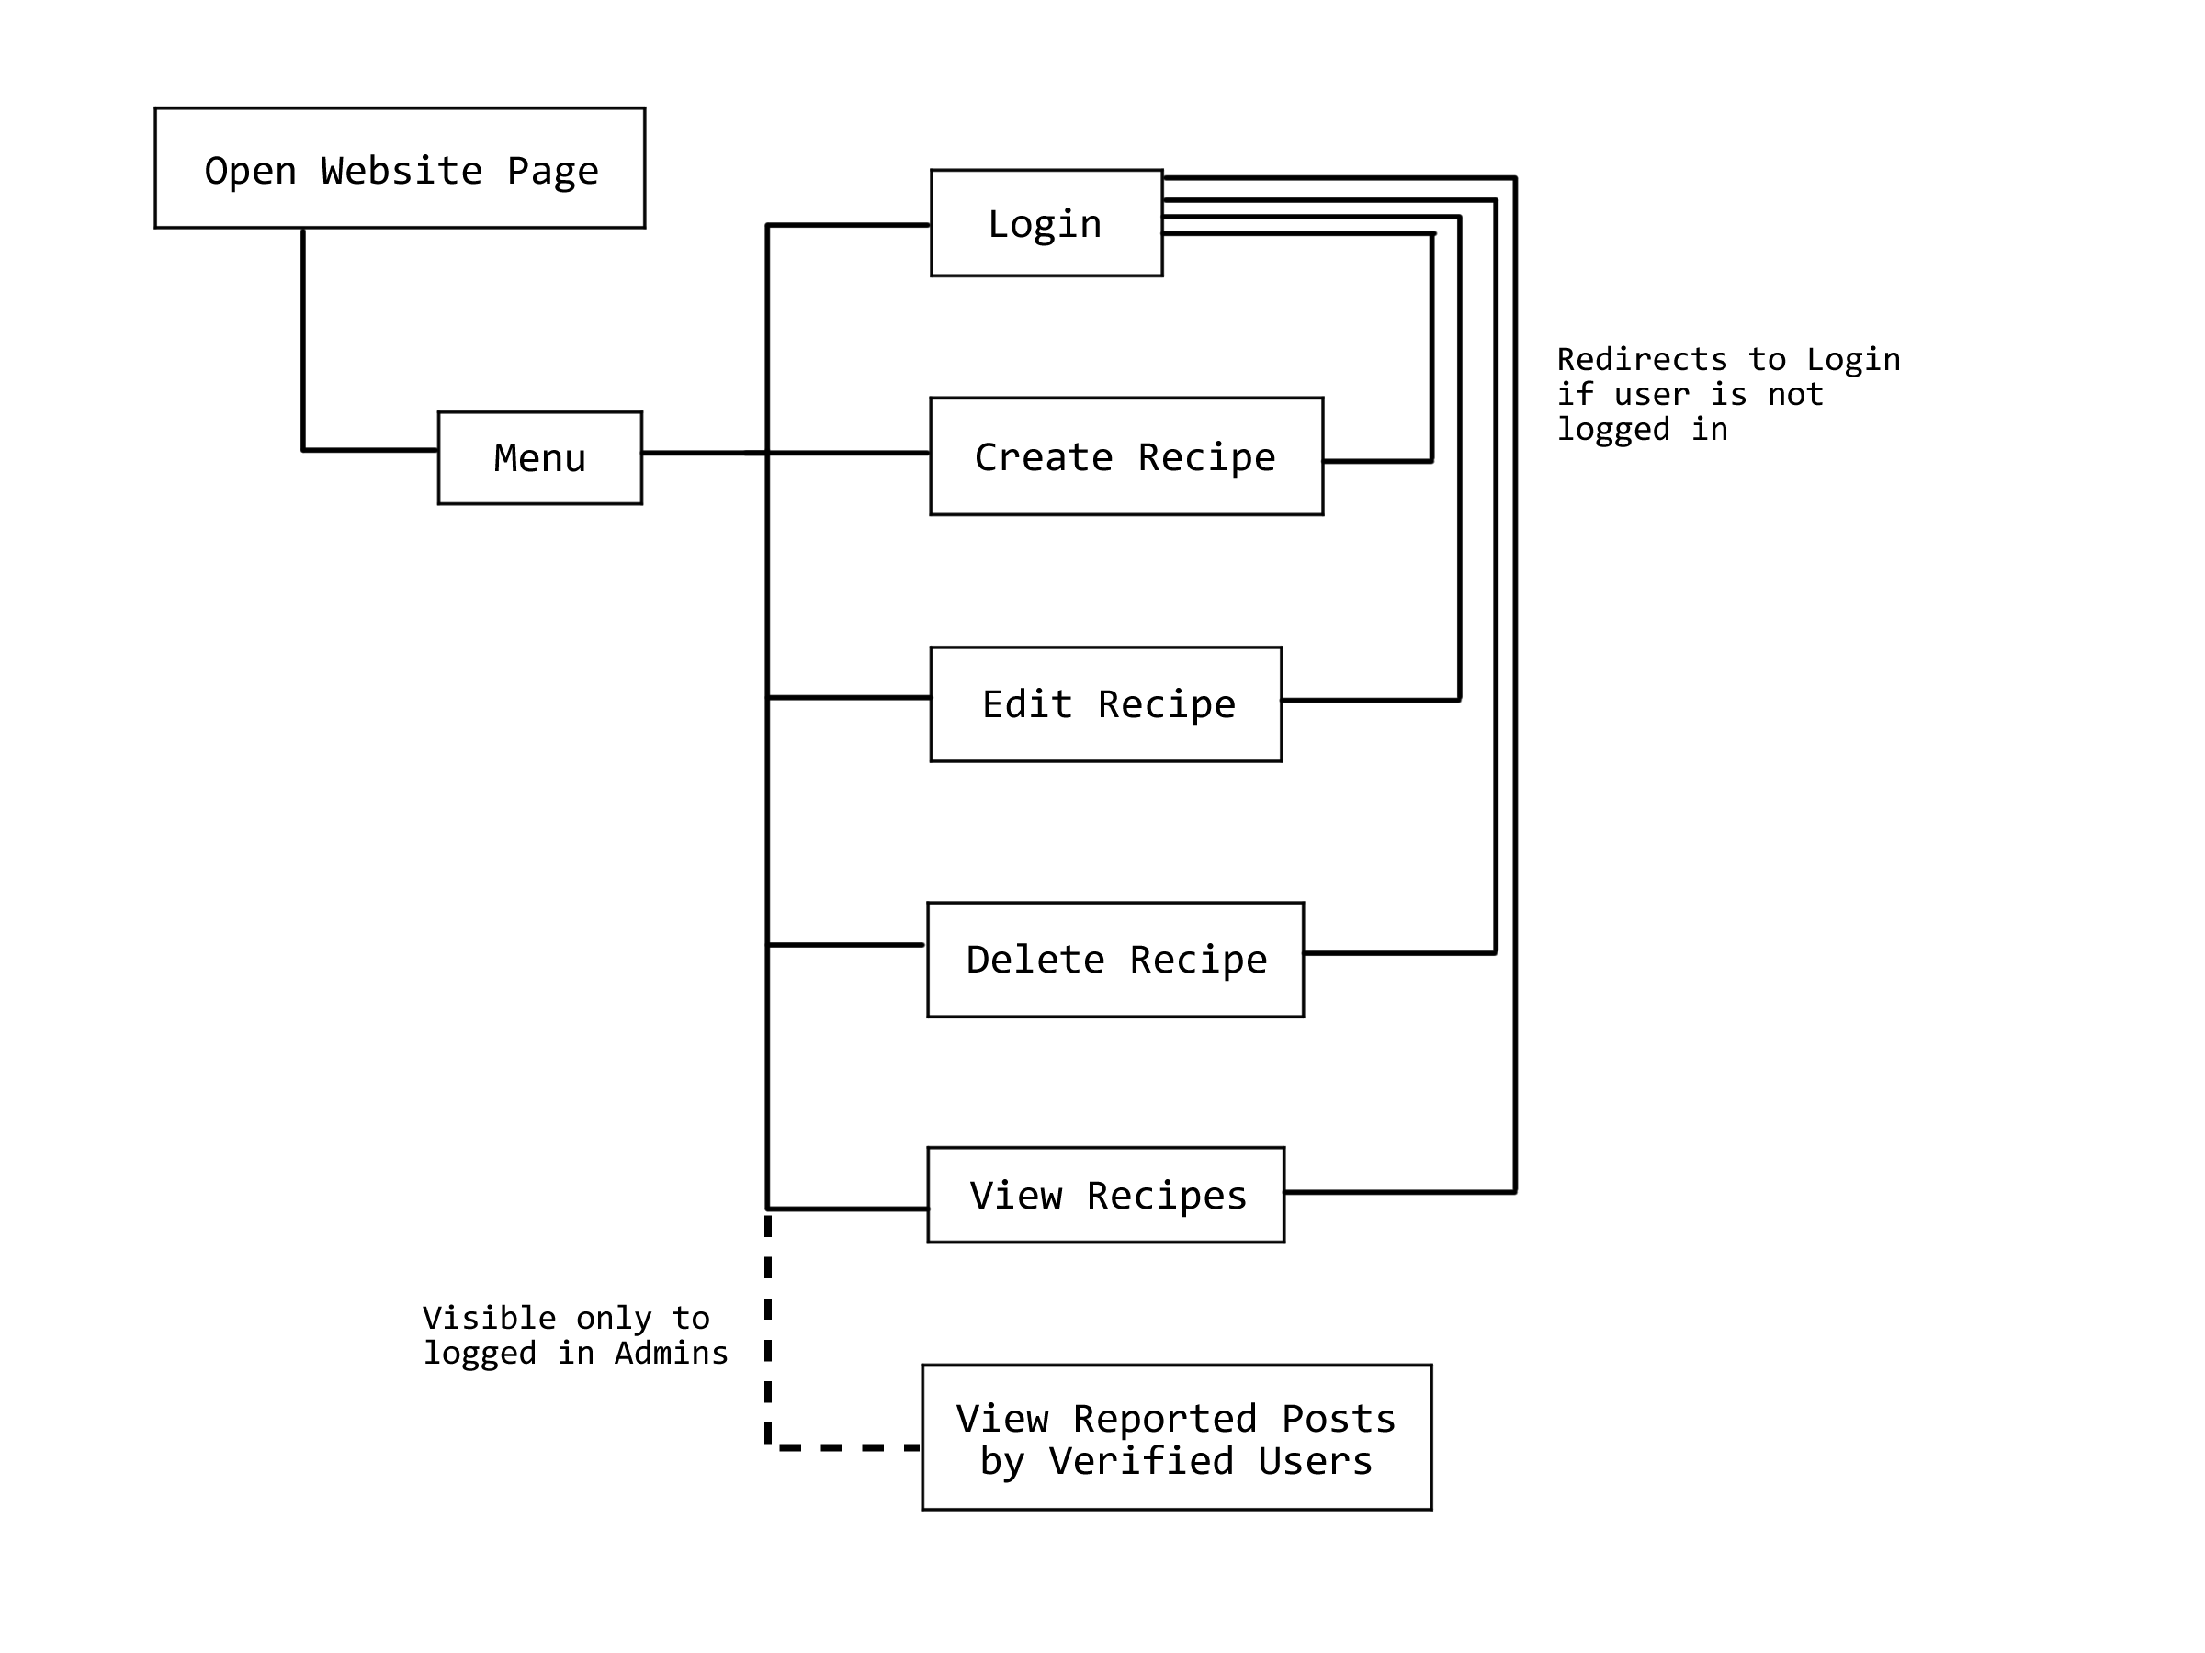

Use Case Scenarios

**Case 1: Create Recipe**

**Purpose:** Create a new recipe entity and add it to the database. Insert tuples into Post, Recipe, and Tags tables.

**User Group(s):** Users

**Input:** Title, tags, description, cooking time, ingredients, instructions.

**Output:** A new Post entity/tuple is created, with Post(ID), Post(Time), and Post(Date) being auto-filled by the program. Post(Username) is filled in with the Username of the User creating the Recipe, and Post(Is_Post_Reported) is set to null. The Post(Type) is set to Recipe, and a new Recipe entity/tuple is created in the Recipe table, and Recipe(PostID) is linked to Post(ID). The Recipes(Title), Recipes(Instructions), Recipes(Ingredients), Recipes(Cooking_Time), and Recipe(Description) attributes are filled based on User input. New Tags/tuples are created for each tag the User adds to the post, using the User input and the Post(ID) of the Post. Upon successfully creating a recipe the user is taken to the page for the Recipe, which will display all relevant information as well as options for editing or deleting the Recipe, which are only seen by the user who posted the Recipe. Failure to post the recipe will give an error message.

**Exception:** None of the fields can be blank. If a field is blank, the form will not be submitted and the page will refresh with alerts telling the user that the empty fields are required.

**Table(s):** Input: Recipes(Title), Recipes(Instructions), Recipes(Ingredients), Recipes(Cooking_Time), Recipe(Description), Tags(PostID), Tags(TagInfo). Post(Username) is gathered from the User trying to create the Post, Post(ID) and Post(TimeStamp) are generated by the database, and Post(Is_Post_Reported) is set to ‘F’ with no user input.

Output: Tuples are inserted into the Post, Recipe, and Tags tables.

**SQL:**

INSERT INTO Post(Username, TimeStamp, Is_Post_Reported)

VALUES( ? , CURDATE() , 'F')

SELECT MAX(ID) FROM Post

INSERT INTO Recipe(PostID, Title, Instructions, Ingredients, Cooking_time, Description)

VALUES( ?, ? , ?, ?, ? , ? )

INSERT INTO Tags(PostId, TagInfo)

VALUES( ? , ? )

**Case 2: Edit Recipe**

**Purpose:** Allow a user to edit a recipe they have already added to the database. This is meant for small changes, such as fixing a typo or adding a forgotten ingredient, so things like the Post(ID) and any associated tags will not be changed.

**User Group(s):** Users with the posts relationship to a particular recipe, where the Post(Username) matches the user’s username.

**Input:** Title, description, cooking time, ingredients, instructions. Note that previously entered data should be returned and presented to the user, whereupon the user will be able to modify the text of leave any part of each as-is.

**Output:** Visibly, the altered fields for the Recipe will change, and in the database all columns for the tuple in Recipe with this Posts Post(ID) will be altered according to user input.

**Exceptions:** Similarly to “create recipe,” no fields can be blank. If this takes place, an error message is displayed telling the user that the field is required.

**Table(s):** Input: Recipes(Title), Recipes(Instructions), Recipes(Ingredients), Recipes(Cooking_Time), Recipe(Description), Post(ID) and Post(Username) are gathered from the webpage.

Output: Any or all of the above tables and fields (not including Post(ID) and Post(Username) ) may be modified, based on what the User input.

**SQL:**UPDATE Recipe

SET Title = ?, Description = ?, Instructions = ?, Ingredients = ?, Cooking_Time = ?

WHERE PostID = ?

DELETE FROM Tags WHERE PostID = ?

INSERT INTO Tags(PostId, TagInfo)

VALUES( ? , ? )

**Case 3: Delete Recipe**

**Purpose:** Remove a recipe entity from the database and all related entities and pages. This also removes any comments and faves relationships.

**User Group(s):** General Users with the posts relationship to the particular recipe.

**Input:** The user will select one of their recipes from a dropdown menu. The webpage will gather necessary information based on the user’s selection.

**Output:** This option will only be available for Users with their Username linked to the Post. On selecting to delete the recipe, the corresponding tuple in the Post table with the Posts ID will be deleted, as well as any tuples in the Faves, Recipe, and Tags tables. Furthermore, any Comments with the RepliesToID field matching the deleted Post will also be deleted, along with the related tuples in the Votes_on table.

**Exception:** No exceptions, the only choices given to the user will be valid inputs, and the option to delete a post will not be available to other Users.

**Table(s):** Input: Post(ID), Post(User), User(Username), Note: These are not input by the user, but collected from the page this function is being called on and the Users logged in status. Only Recipe subtypes can be deleted

Output: Post Recipe, Comments, Tags, Votes_on, and Faves tables may all be modified.

**SQL:**

DELETE FROM Post WHERE ID = ?

**Case 4: View Reported Posts by Verified User**

**Purpose:** To allow an Admin to view verified users with reported posts

**User Group(s):** Admin

**Input:** Admin must be logged in, no user input beyond accessing the page is required.

**Output:** A table listing all of the verified users with Posts containing the Is_Post_Reported flag set to true, and the number of reported posts for each user. Note: a “verified” user is a User with the isVerified flag set to true. The list of verified users is created by looking at all the Posts with the Is_Post_Reported flag set to true, and then looking at all the isVerified flags of Users related to these reported Posts. The number of reported posts for each verified user is calculated by looking at all the tuples in the Posts table with both the Username of the verified user and the Is_Post_Reported flag set to true.

**Exception:** If there are no verified users with reported posts, the results page will be blank, but otherwise no exceptions will occur.

**Table(s):** Input: None

Output: User(Username), number of reported posts (derived)

**SQL:**

SELECT u.Username, COUNT(*)

FROM User as u, Post as p

WHERE u.Username = p.Username and u.isVerified = 'T' and p.Is_Post_Reported = 'T'

GROUP BY u.Username

**Case 5: View Recipes (Sort by: #of Faves)**

**Purpose:** This is a report use case in which a user sorts all the recipes posted under their username into list, ordered by the number of favorites each recipe has, from highest to lowest.

**User Group(s):**  All Users

**Input:** Nothing on the user end; they should be able to click a “View Recipes Sorted by Number of Favorites” link and the database will do the sorting. On the back end, clicking this link will input the User’s Username into the Posts table to find all of the posts that they have made, Post(Username).

**Output:** The output is a table containing all the Posts made by a User and the number of favorites for each Post. The Posts made by the user will be compiled by searching the Post table for tuples with the User’s Username. The number of favorites for each post will be calculated by looking at the Faves table and finding all the tuples with a Post(ID) of a post made by the user, for every post made by the user. Posts with 0 faves will not be shown.

**Exceptions:** If User does not have any posts, the results will be blank, and it none of their posts have been favorited then the number of favorites will be 0. The User must be logged in to view this page.

**Table(s):** Input: Post(Username)

Output: Post(ID), number of favorites for each recipe (derived)

**SQL:**

SELECT p.Title, (SELECT COUNT(*)

FROM Faves AS f

WHERE f.PostID = p.PostID

GROUP BY p.PostID) as NumFavorites

FROM Faves AS f, Recipe AS p, Post as o

WHERE f.PostID = p.PostID and p.PostID = o.ID and o.Username = ?

GROUP BY p.PostID

SELECT Recipe.Title from Recipe, Post, User

WHERE User.Username = Post.Username and ID = PostID and User.Username = ? and Recipe.PostID NOT IN (SELECT Faves.PostID from Faves, Recipe, Post

WHERE User.Username = ? group by Faves.PostID)

**Case 6: Login**

**Purpose:** To allow a person viewing the website to login using their username and password, and thus gain access to User functions.

**User Group(s):** Guest (anyone not logged in to the website)

**Input:** Username, password. This input is compared to tuples in the User table to find a tuple with a matching username and password. Looks at User(Username) and User(Password) columns.

**Output:** The site directs the User (now logged in) to the menu. No tables are modified.

**Exception:** If the Username and Password combination does not match any tuples in the User table, the login will be unsuccessful. An error message will be displayed and the Guest may try logging in again.

**Table(s):** Input: User(Username), User(Password)

Output: None, but user will be logged in to the website

**SQL:**

SELECT Username, isVerified, Type FROM User

WHERE Username = ? and Password = PASSWORD( ? )

SQL Testing

**Use Case 1: Create Recipe**

**SQL Statement:**

INSERT INTO Post(Username, TimeStamp, Is_Post_Reported)

VALUES( ‘cat’ , CURDATE() , 'F')

**Description:**

This is the first part of entering the recipe into the database. The ID is generated automatically and increments. Post is not reported by default. Our test user here is cat.

**Predicted Output:**

This should generate a single tuple with an ID of 66, Username ‘cat’, report value of ‘F’, and the current date, as generated by the CURDATE() function.

**Actual Output:**

Table Rows:

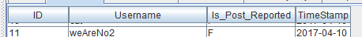

Before:

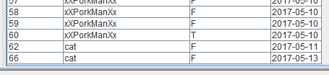

After:

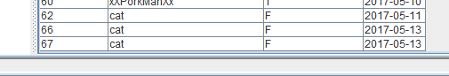

**SQL Statement:**

SELECT MAX(ID) FROM Post

**Description:**

This statement selects the maximum ID value from Post.

**Predicted Output:**

This should select 67, the ID that we just generated, as a single tuple.

**Actual Output:**

Result:

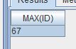

**SQL Statement:**

INSERT INTO Recipe(PostID, Title, Instructions, Ingredients, Cooking_time, Description)

VALUES( ‘67’ , ‘test0’ , ‘test1’ , ‘test2’ , ‘10’ , ‘test3’ )

**Description:**

Now that we’ve selected the max value from Post, we’re going to use that to build our recipe tuple. Simple values are used for each of the text values for clarity.

**Predicted Output:**

A new tuple in Recipes will be created with the given values inserted.

**Actual Output:**

Table Rows:

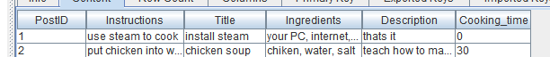

Before:

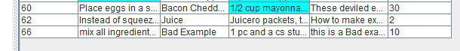

After:

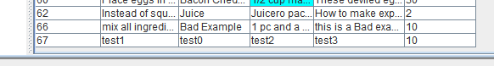

**SQL Statement:**

INSERT INTO Tags(PostId, TagInfo)

VALUES( ‘67’ , ‘tag’ )

**Description:**

This SQL creates a new tag tuple with the corresponding PostID and TagInfo. Note that this is also used in the second use case to re-insert tags into the database.

**Predicted Output:**

Should be a single tuple, with PostID 66 and TagInfo ‘tag’.

**Actual Output:**

Table Rows:

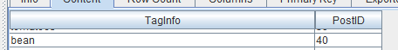

Before:

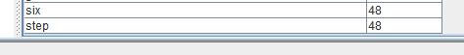

After:

Note: For some reason, Squirrel is not showing all the tuples in the Tags table. However, an SQL query will return the expected tuples.

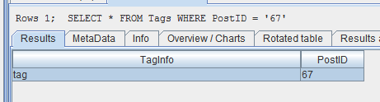

**Use Case 2: Edit Recipe**

**SQL Statement:**

UPDATE Recipe

SET Title = ‘edit0’ , Description = ‘edit3’ , Instructions = ‘edit1’ , Ingredients = ‘edit2’ , Cooking_Time = ‘20’

WHERE PostID = ‘67’

**Description:**

Updates the recipe tuple corresponding to the given PostID.

**Predicted Output:**

An updated tuple at the given PostID.

**Actual Output:**

Table Rows:



Before:



After:

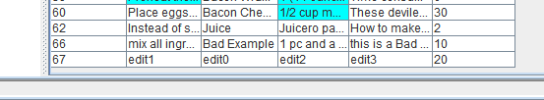

**SQL Statement:**

DELETE FROM Tags WHERE PostID = ‘67’

**Description:**

Deletes all tuples with the inputted PostID.

**Predicted Output:**

Should do exactly as description says.

**Actual Output:**

Before:



After:





**Use Case 3: Delete Recipe**

**SQL Statement:**

DELETE FROM Post WHERE ID = ‘67’

**Description:**

This SQL deletes the Post tuple with the given ID. Since the table definitions cascade, every tuple that references this PostID.

**Predicted Output:**

The Post, Recipe, and Tags tuples for 67 should all be gone.

**Tables Before:**

Post:



Recipe:



Tags:



**Actual Output:**

Post:



Recipe:



Tags:



**Use Case 4: Reported Posts by Verified Members**

**SQL Statement:**

SELECT u.Username, COUNT(*)

FROM User as u, Post as p

WHERE u.Username = p.Username and u.isVerified = 'T' and p.Is_Post_Reported = 'T'

GROUP BY u.Username

**Description:**

This SQL selects all reported posts by Users with the verified user designation.

**Predicted Output:**

A table with two columns. The first contains the name of a verified user, and the second contains the number of reported posts they’ve made.

**Actual Output:**

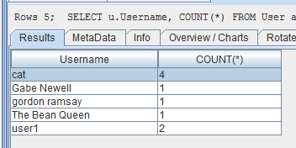

This matches the data in the database. All users shown are verified, and all reported posts are accounted for.

**Use Case 5: Show User Recipes**

**SQL Statement:**

SELECT p.Title, (SELECT COUNT(*)

FROM Faves AS f

WHERE f.PostID = p.PostID

GROUP BY p.PostID) as NumFavorites

FROM Faves AS f, Recipe AS p, Post as o

WHERE f.PostID = p.PostID and p.PostID = o.ID and o.Username = ‘cat’

GROUP BY p.PostID

ORDER BY NumFavorites DESC

**Description:**

This SQL selects a User’s recipes and sorts them by the number of Faves those recipes have. This doesn’t display the posts without any faves.

**Predicted Output:**

See description.

**Actual Output:**

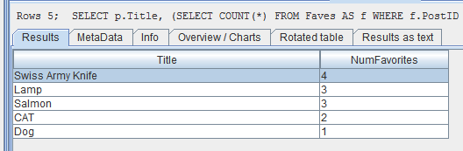

Which is the correct data. (For faves table, see uploaded data).

**SQL Statement:**

SELECT Recipe.Title from Recipe, Post, User

WHERE User.Username = Post.Username and ID = PostID and User.Username = ‘cat’ and Recipe.PostID NOT IN (SELECT Faves.PostID from Faves, Recipe, Post

WHERE User.Username = ‘cat’ group by Faves.PostID)

**Description:**

This SQL shows the posts by the given user which don’t have any Faves.

**Predicted Output:**

See description.

**Actual Output:**

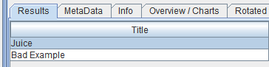

Which is the correct data. (For faves table, see uploaded data).

**Use Case 6: Login**

**SQL Statement:**

SELECT Username, isVerified, Type FROM User

WHERE Username = ‘cat’ and Password = PASSWORD( ‘cat’ )

**Description:**

This retrieves user information based on the given username and password. Uses native password function.

**Predicted Output:**

A tuple with the Username and its attributes.

**Actual Output:**

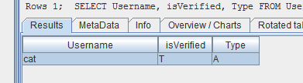

**Helper Methods**

**SQL Statement:**

SELECT Title, PostID FROM Recipe, Post

WHERE PostID = ID and Username = ‘cat’

**Description:**

This retrieves all the Recipe titles and IDs from a given user.

**Predicted Output:**

A table with 2 columns: the PostID and the Recipe title for each recipe created by the user.

**Actual Output:**

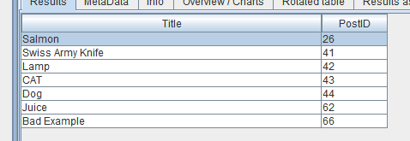

**SQL Statement:**

SELECT Title, Description, PostID FROM Recipe, Post

WHERE PostID = ID and Username = ‘cat’

**Description:**

This SQL returns essentially the same information as the other helper method, with the addition of the recipe description.

**Predicted Output:**

A table with 3 columns: the PostID and the Recipe title for each recipe created by the user, along with each recipe’s description.

**Actual Output:**

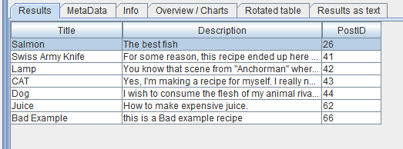

Webpage Testing

Note: The webpages tested did not have CSS formatting

**Use Case 1: Create Recipe**

**Description:**

This webpage contains labeled text boxes to input the desired data. Once every box has been filled (required) and the submit button has been clicked, that data is inserted as a new tuple into the database. In order to enter this page, you must be logged in, otherwise, you will be redirected to the login page. Here we will be making a recipe under the username cat.

**Predicted Output:**

A new tuples are inserted into the Post, Recipe, and Tags tables containing the information typed into the form.

**Actual Output:**

Post, Recipe, and Tags tables before creating a new recipe:

Post:

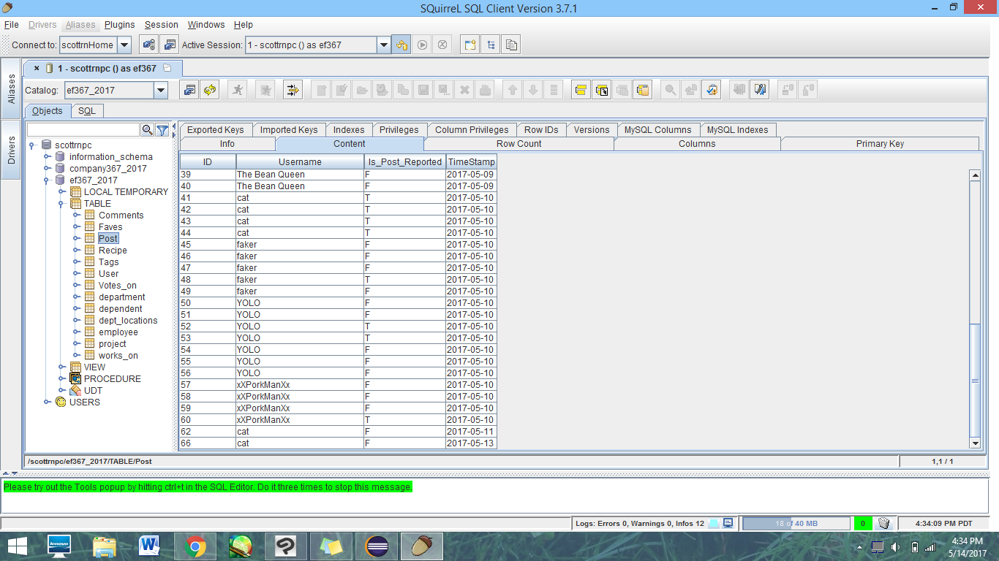

Recipe:

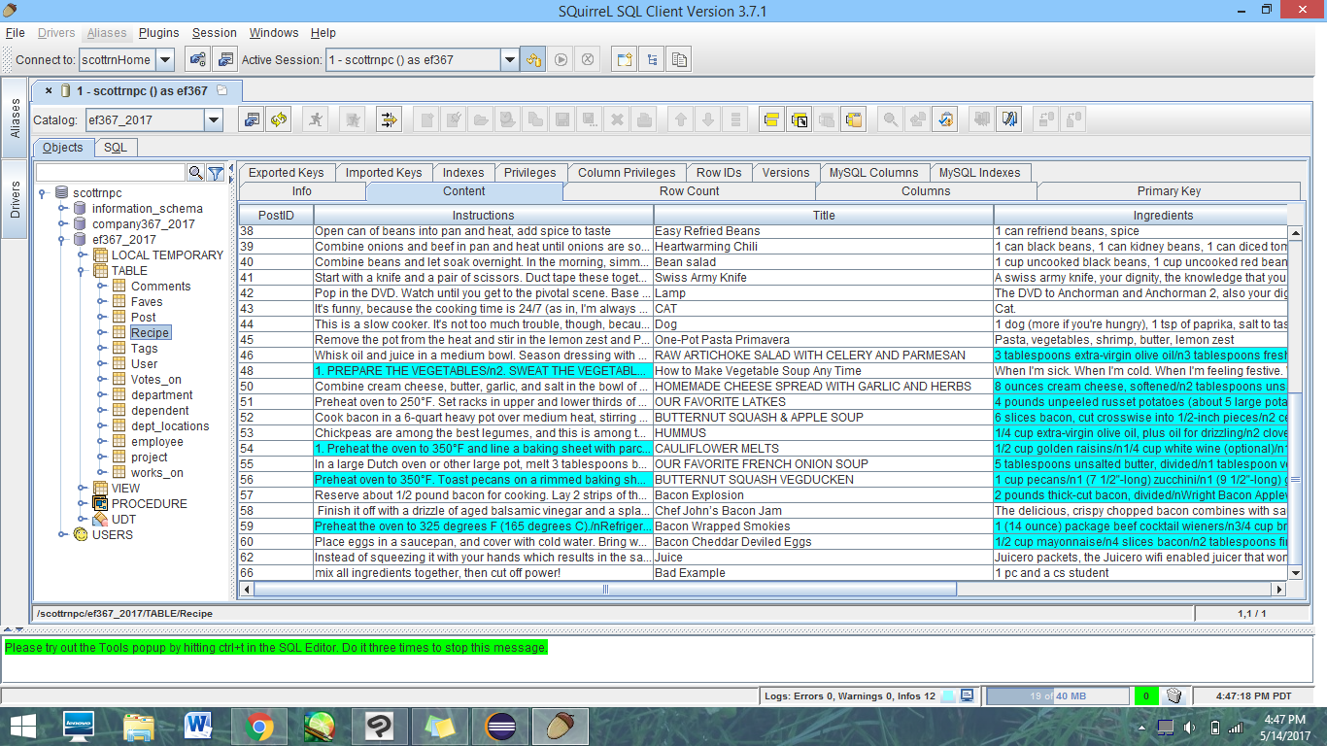

Tags:

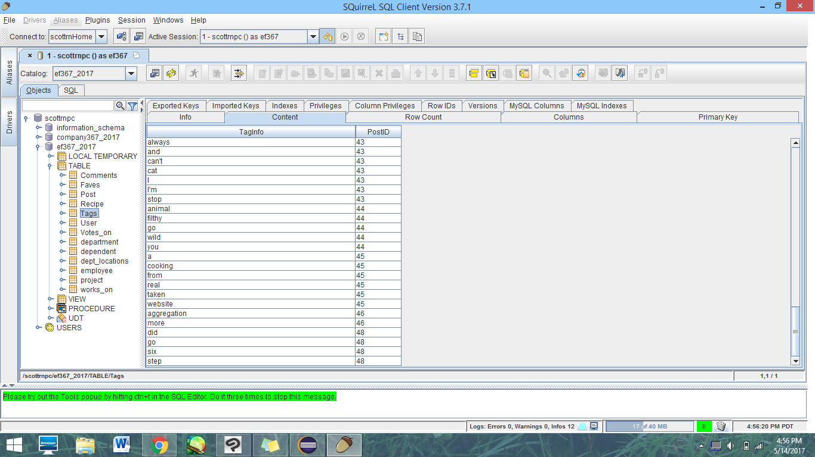

**Recipe Input:**

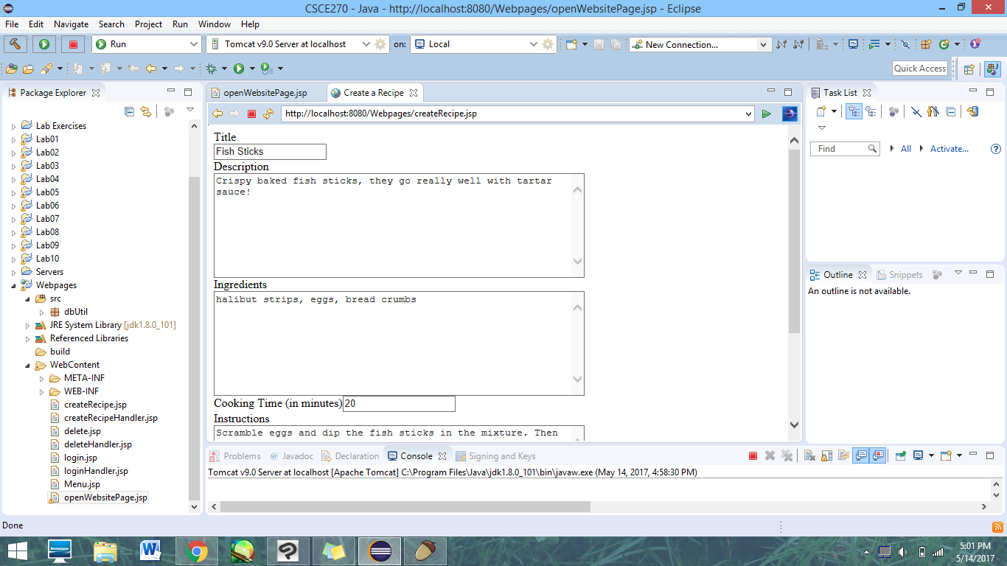

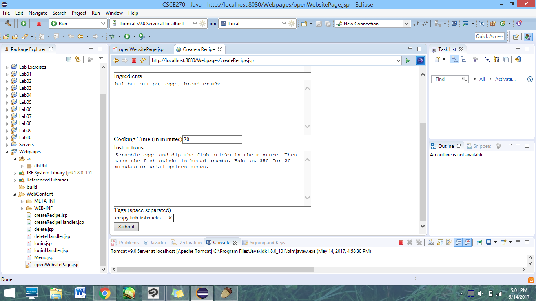

Based on this input, we expect a Recipe with the title “Fish Sticks” to be created, along with associated tuples in the Post and Tags tables. Upon entering the data, the website displays a message indicating these tuples were inserted successfully.

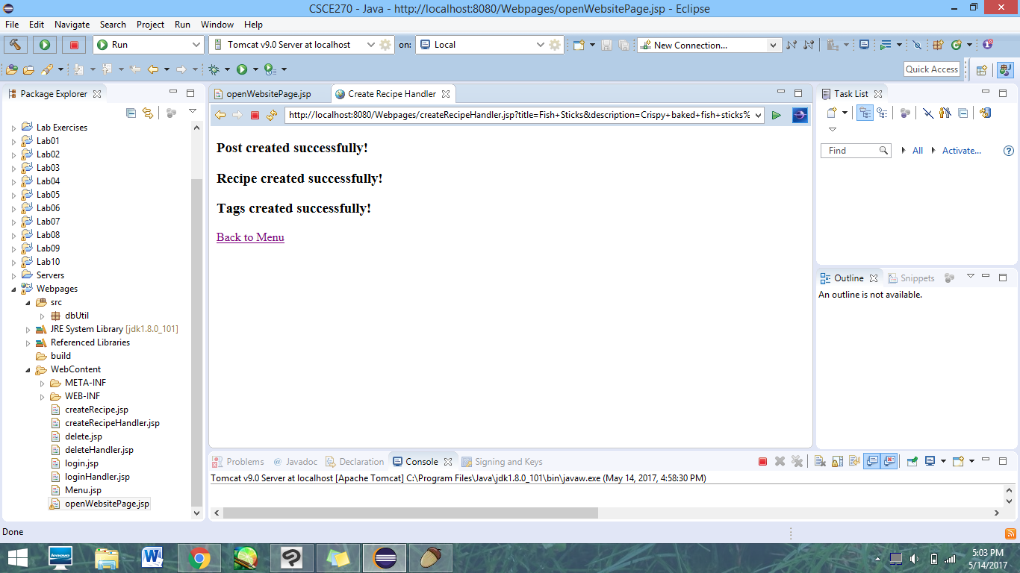

If the user leaves any fields blank, they will be prompted to fill it out before the form is submitted.

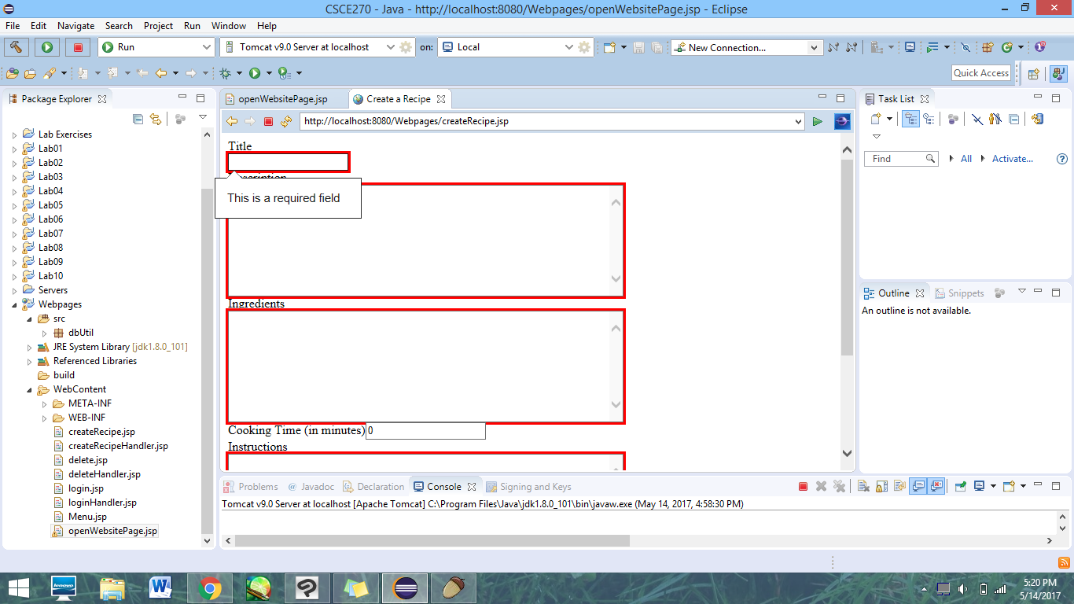

**Recipe Output:**

Note: The only output visible to the user is the page that indicates that the recipe was created successfully. Also, multiple tests were being done at the time, so extra tuples have been created.

Post:

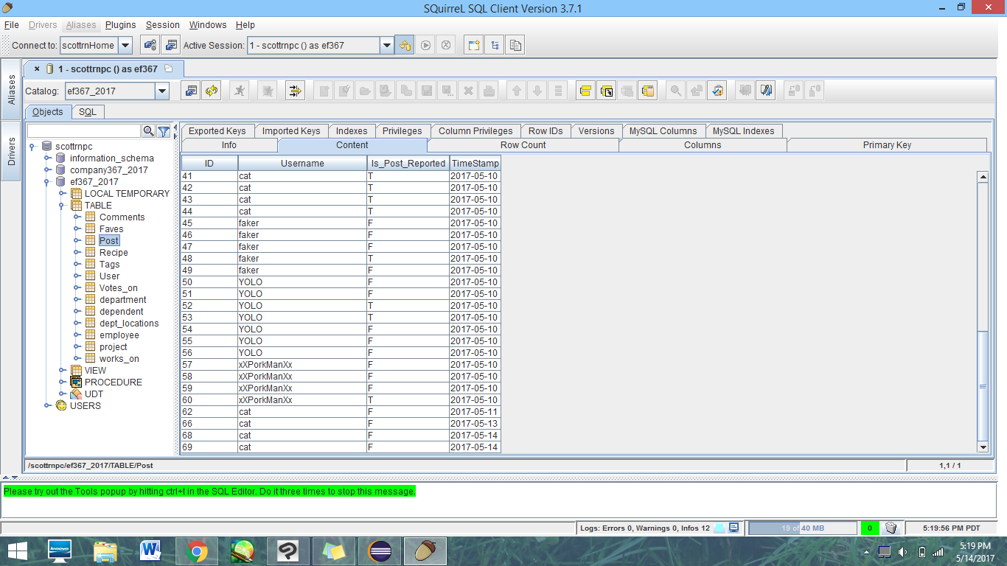

Recipe:

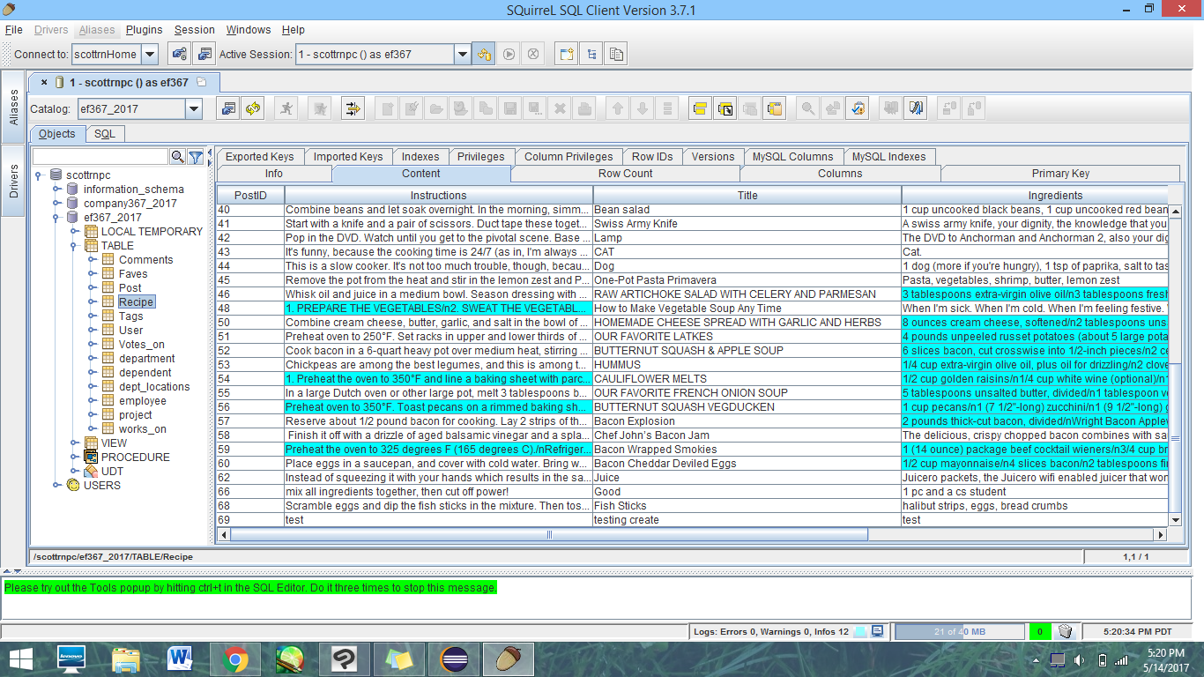

Tags:

Note: For some reason the table in Squirrel was not updating correctly, even though information was inserted. An SQL query returns the expected information, even if it does not show in the tables.

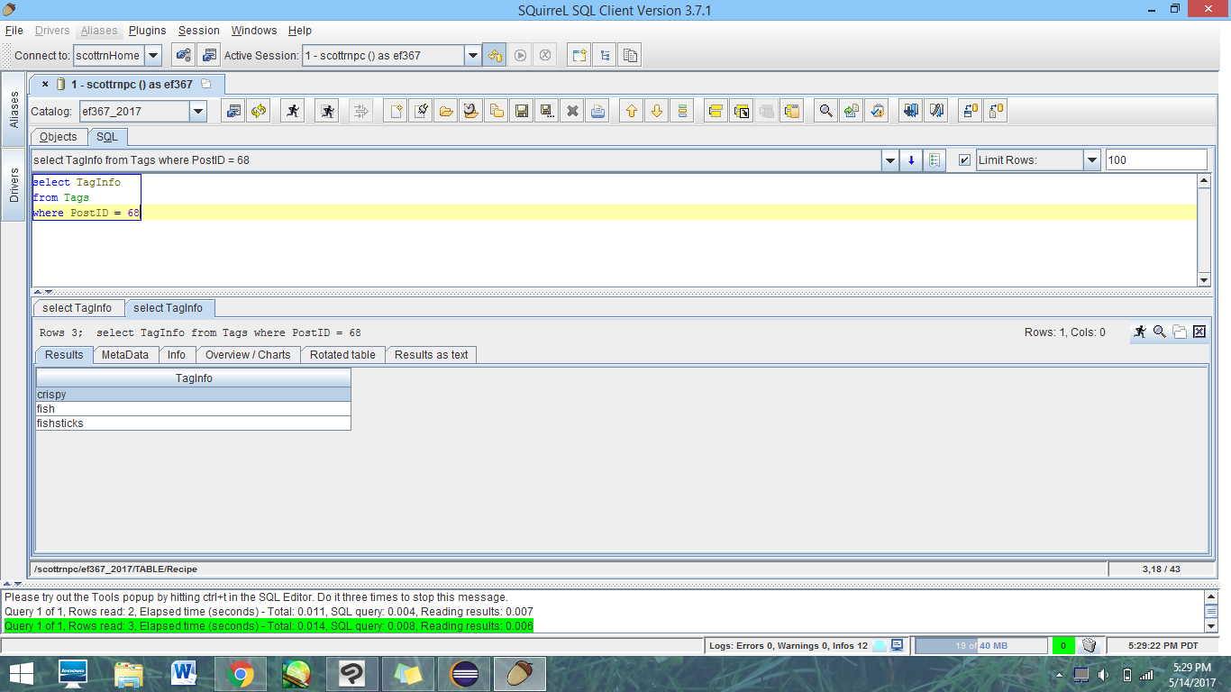

**Use Case 2: Edit Recipe**

**Description:**

This page allows a user to update a tuple in the Recipes table of the recipes that they made. It contains input boxes identical to use case 1. You cannot use this page to update tags (we agreed this function’s use is primarily to fix description typos, so we limited its scope). In order to enter this page, you must be logged in, otherwise, you will be redirected to the login page. *Our test user here is “cat”.*

**Predicted Output:**

The user’s chosen recipe will be updated with the new data. The post’s ID will not be changed.

**Actual Output:**

Recipe table for cat’s recipes before website operation:

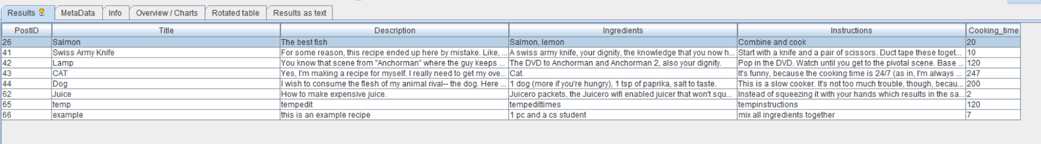





Clicking on Edit Recipe from the menu brings the user to this page, designed to allow a user to select a recipe that they made using the dropdown menu:



After they select a recipe and click on the continue button, they are presented with a page much like the create a recipe page. It contains all of the stored text from the tuple, which a user can then edit:

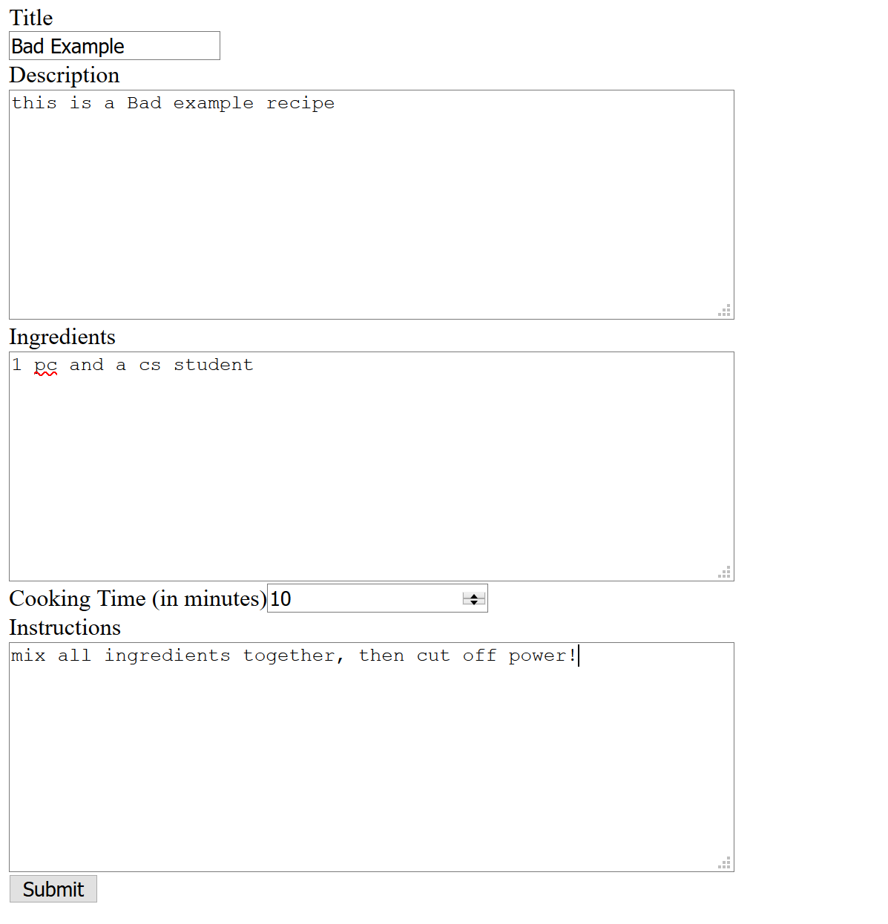

When they click submit, they are shown this if it was edited successfully:

After the edit, cat’s recipes look like this in the Recipe table:

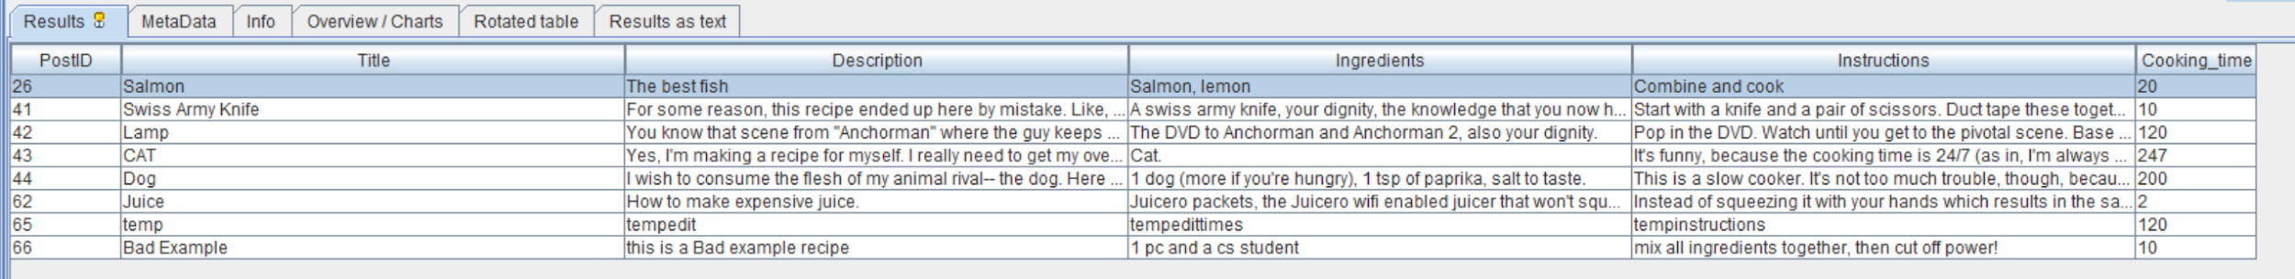



**Use Case 3: Delete Recipe**

**Description:**

This page allows a user to delete a tuple in the Recipes table of the recipes that they made. It contains a selection screen identical to use case 2. In order to enter this page, you must be logged in, otherwise, you will be redirected to the login page. *Our test user here is “cat”.*

**Predicted Output:**

The recipe that the user selected should get deleted.

**Actual Output:**

Recipe table for cat’s recipes before website operation:



Clicking on Delete Recipe from the menu brings the user to this page, designed to allow a user to select a recipe that they made using the dropdown menu:

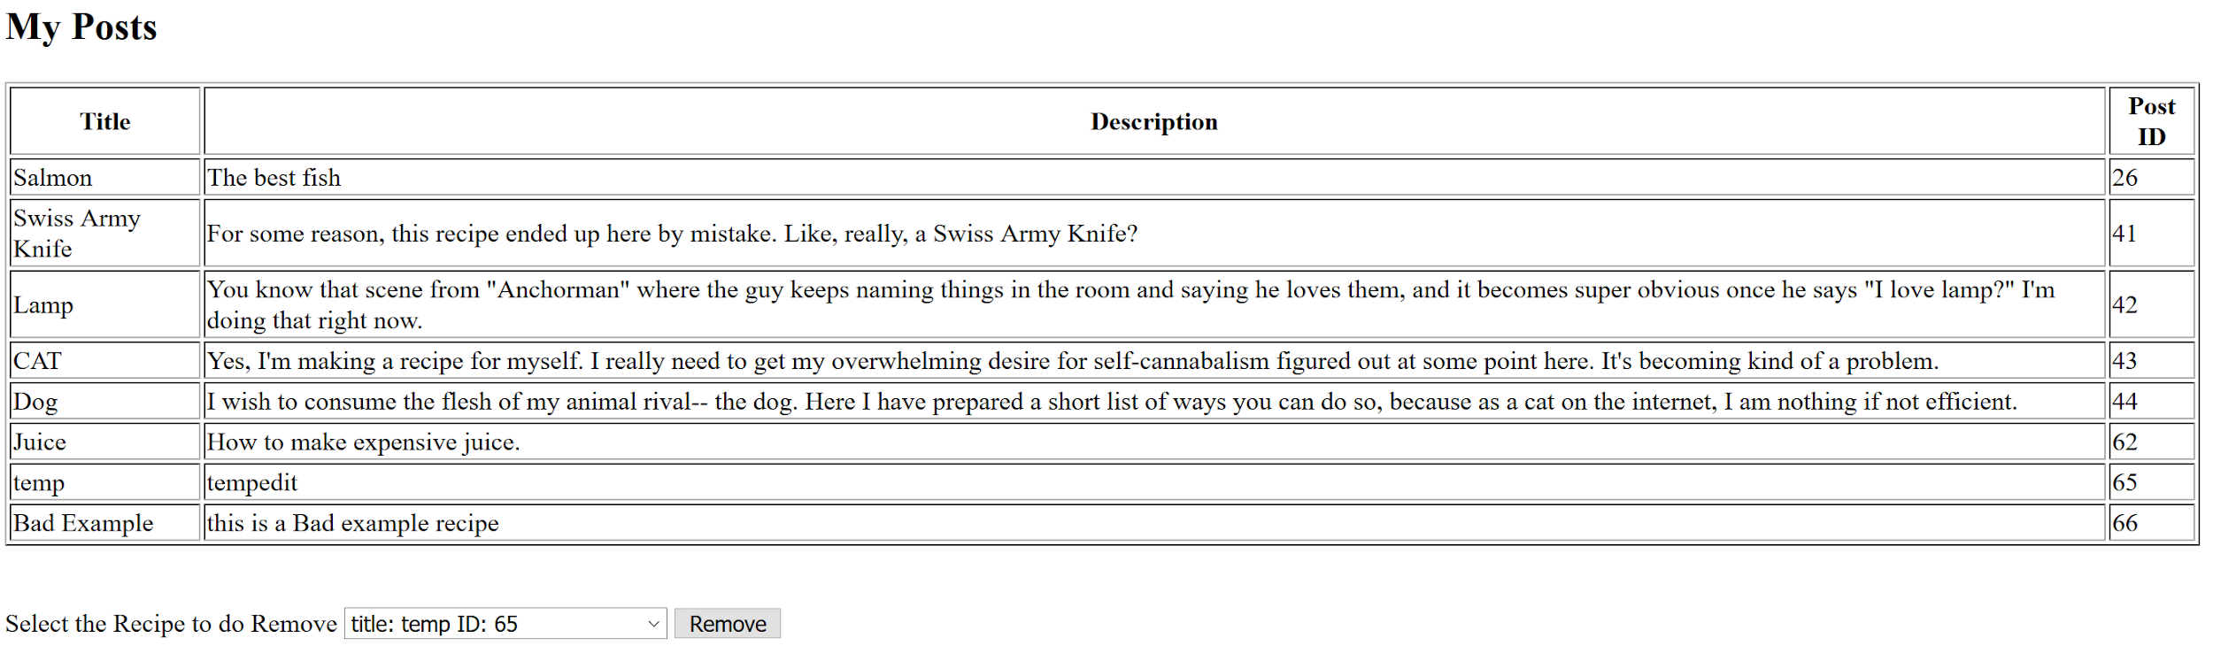

When successful, the website forwards to this:



After deleting the recipe “temp” using the website:

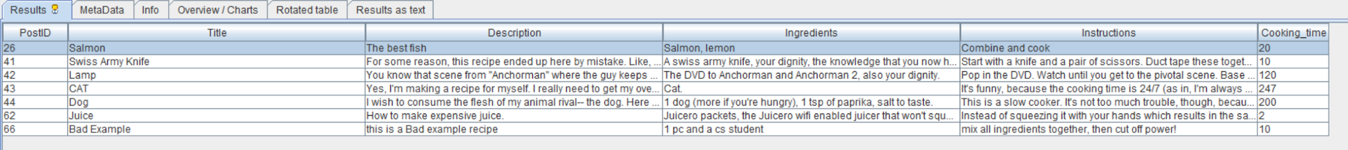

**Use Case 4: Reported Posts by Verified Users**

**Note:** Verified *does not* mean a user’s email has been verified. A Verified user is a celebrity or person of some fame that the developers give a different status than other users so that general users know these accounts are from the real deal and not someone pretending to be this celebrity or person of fame. This mirrors Twitter’s idea of “Verified”. Note that on our website, a Verified user has the same functions as a General user.

**Description:**

This page, *only accessible to admins* (users who are of type admin DO have different functionality), allows an admin to see a report containing the number of posts by a verified user that have been reported (a reported post is a flagged post deemed by a member of our community to be inappropriate). In order to enter this page, you must be an admin, and thus you must be logged in to see it. *Our test user here is “cat”, as cat is an admin.*

**Predicted Output:**

The report containing the number of reported posts by users that are verified.

**Actual Output:**

In the database, here is a table containing users, whether they are verified, the ID of a post they made, and whether or not that post is reported (note: posts can be comments or recipes)*:

*\*Note: This data was retrieved in Squirrel using this SQL made just for testing purposes:*

*Select u.Username, u.IsVerified, p.ID, p.Is_Post_Reported*

*from User as u, Post as p*

*where u.Username = p.Username*

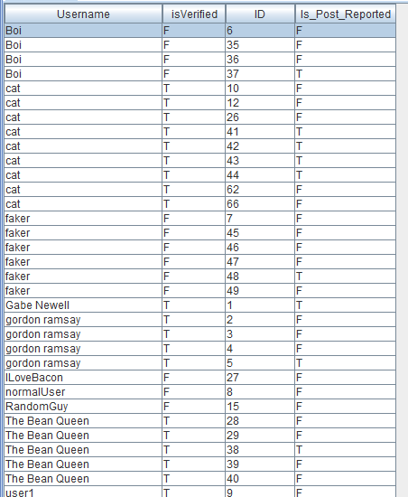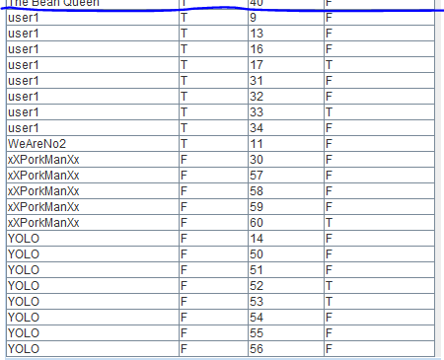

When user clicks on “View Reported Posts by Verified User”, the webpage displays this:

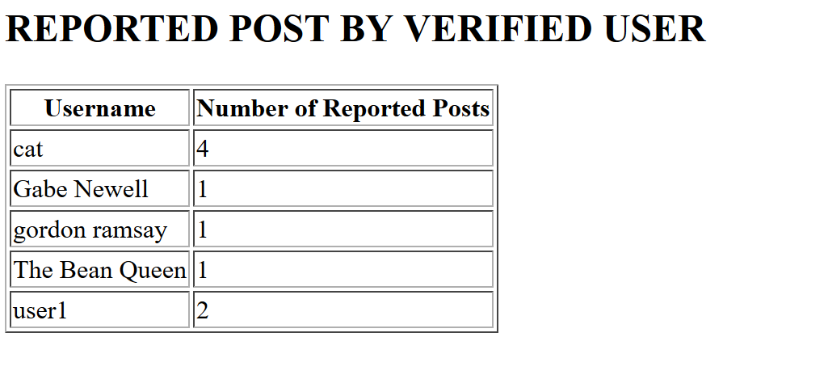

**Use Case 5: Show User Recipes**

**Description:**

This page allows a user to see a report of their posts by the number of people who favorited them, in order of largest number of faves to smallest. In order to enter this page, you must be logged in, otherwise, you will be redirected to the login page. *Our test user here is “cat”.*

**Predicted Output:**

A report of their posts by the number of people who favorited them, in order of largest number of faves to smallest.

**Actual Output:**

This use case required two SQL statements to make work, the number of favorites for posts of a user that have favorites, and a statement that returns posts from a user with no favorites. The posts with no favorites by the user (meaning they don’t appear in the Faves table but appear in the posts by that user) are added to the end of the table, along with “0” for the number of faves column on the webpage.

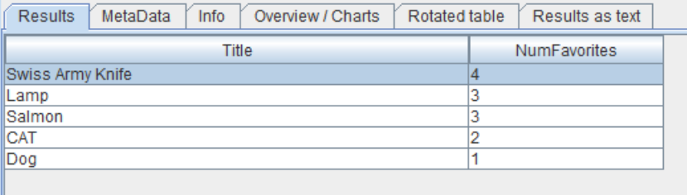

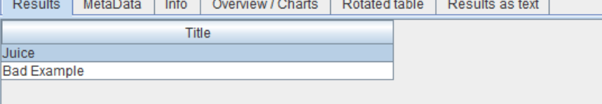

When user ‘cat’ clicks on “View recipes by number of favorites” from the menu, the webpage looks like this:

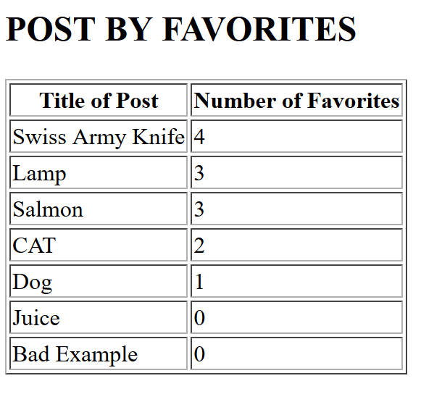

**Use Case 6: Login**

**Description:**

This webpage contains two input text boxes and a submit button, one for username and one for password. Requiring input, it checks the password against the hashed one in the database. If the password and username match, then it logs in the user.

**Predicted Output:**

The login status display on the menu page will display username, Verified Status and Admin Status (True or False for both attributes). The Menu will display use case 4 if the user is an admin, and not display it if the user is not an admin.

**Actual Output:**

The menu page before the user is logged in (notice how “View Reported Posts by Verified User” is not an option):

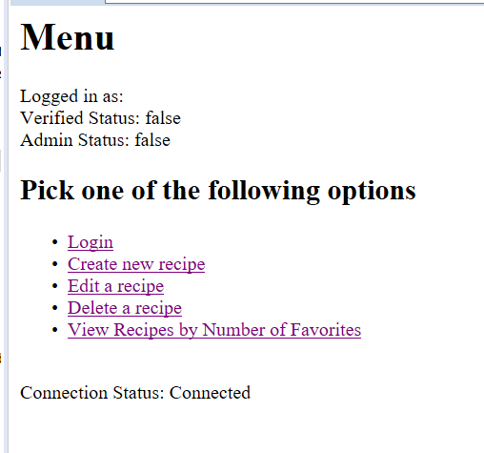

The login page (note: all passwords to our test accounts are also the usernames. We do not advocate for this in real accounts):

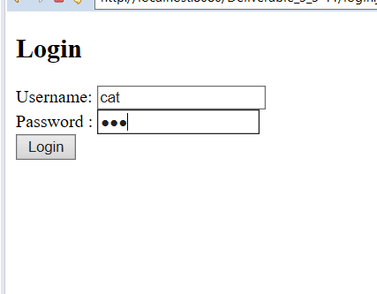

The menu page after this admin has logged in (note the presence of “View Reported Posts by Verified User”):

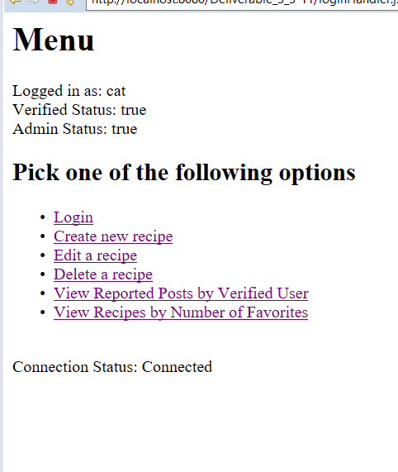

When logged in as a non-admin account, the option disappears:

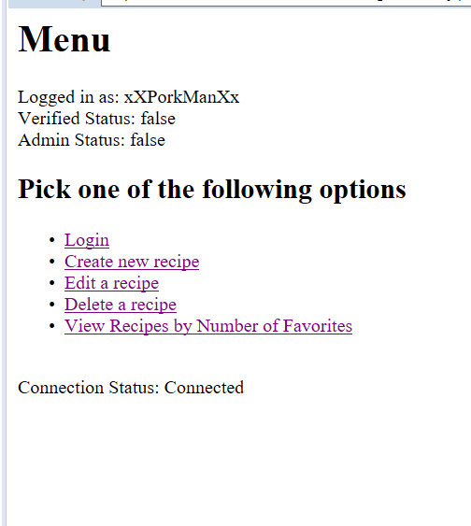

When a user submits the wrong username and password combo, they are redirected to a page containing a link that links back to the login page:

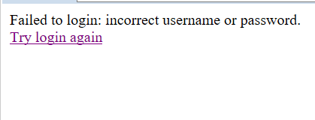

Special Features

**CSS**

**Description:**

Our website’s final version has background photos that seth edited in photoshop (blur and darkening in order to make outer text readable), and some css stylings.

**Our css stylings include:**

* input[type=”submit”] - This formats all of our buttons for forms. Color controls text, border: none makes the button look cleaner by eliminating the border, padding, text-align and font-size make the button larger and center the text inside.

Here is our opening page, including a button:

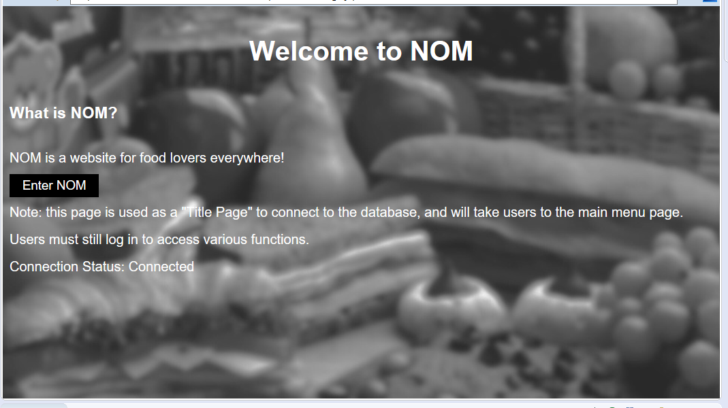

* * all text is formatted white, aside from some exceptions. The pages that use dropdowns (option) have their own css which avoids using the css *, due to the text color in the box being white. Perhaps there’s a way to make an exception so that the text in the boxes, once selected, is not white, but for now, our dropdowns will simply have a different css style (the background is white - not ideal for white text).
* h1, h2, h3, li - These are all aligned to the center and, aside from h3, all have white text.
* input, textarea - the text color has been changed to black in order for text to show up inside the boxes (averts another white on white background problem).
* ol and ul have list-style: none in order to avoid bullet points on the far left of the screen.
* The html is using font-family: sans-serif because it’s a pretty safe, clean font in terms of ui design. A background image is set via background-image, and background-size: cover compensates for the pictures being large. The line-height is at 2, the equivalent of doublespace.
* The links, ‘a’ and ‘a:hover’ have white text and blue text, respectively. That way when you hover over them, the text changes to blue indicating you can click on them.

There are four different stylesheets: one solving the aforementioned text problems for pages that have dropdown menus (“option”) but otherwise identical to the linkstyle. The linkstyle is what each use case is using, and that is simply to change the background. The menustyle is only used so that the menu can have a different background photo, and the homepage similarly has a different background photo. The homepage has already been displayed, so the other three styles are displayed below:

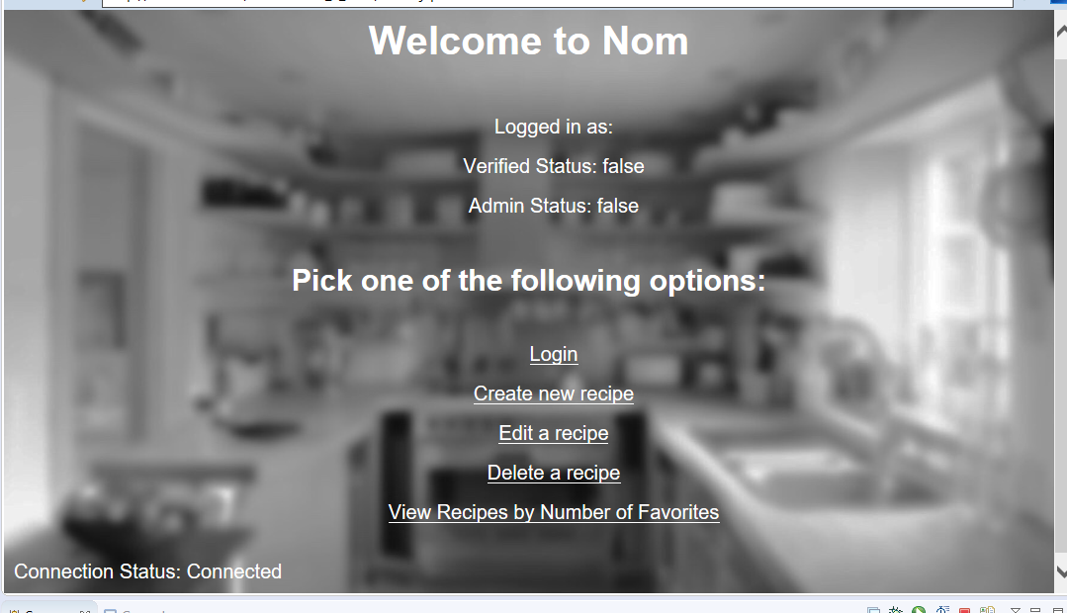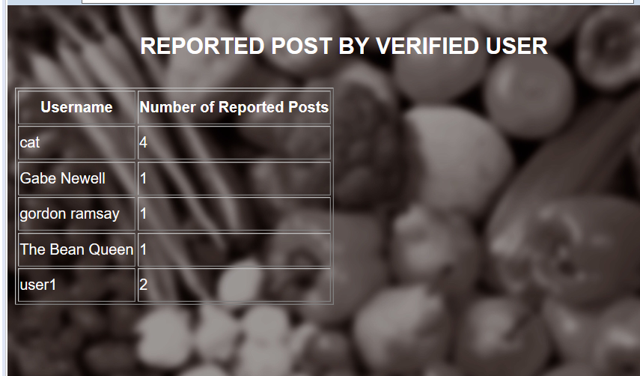

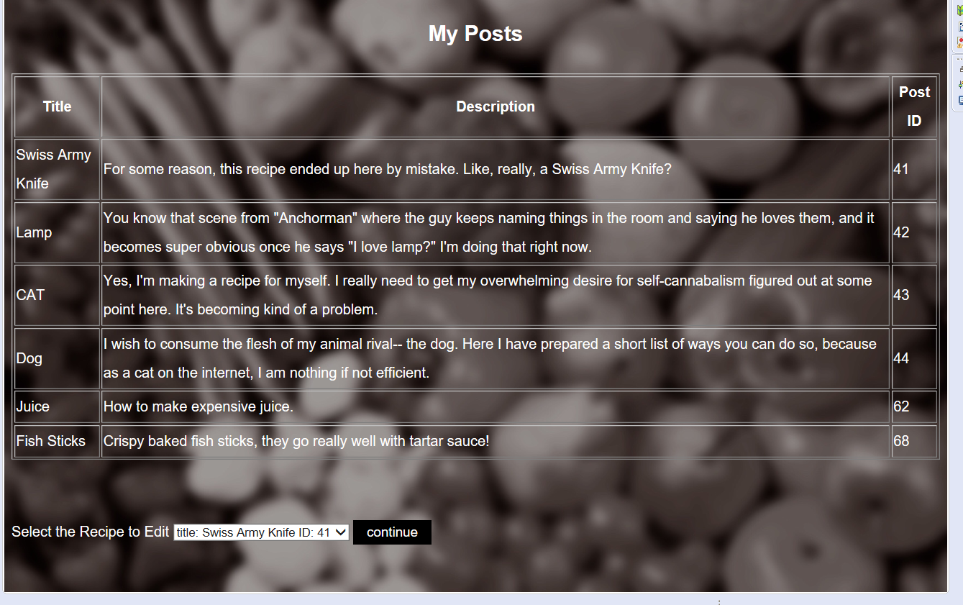

Notice how the text inside of the option is black on a white background, and thus, visible.